Project 1

CSE 321 – Embedded Systems

Andrew Schick

Code Template

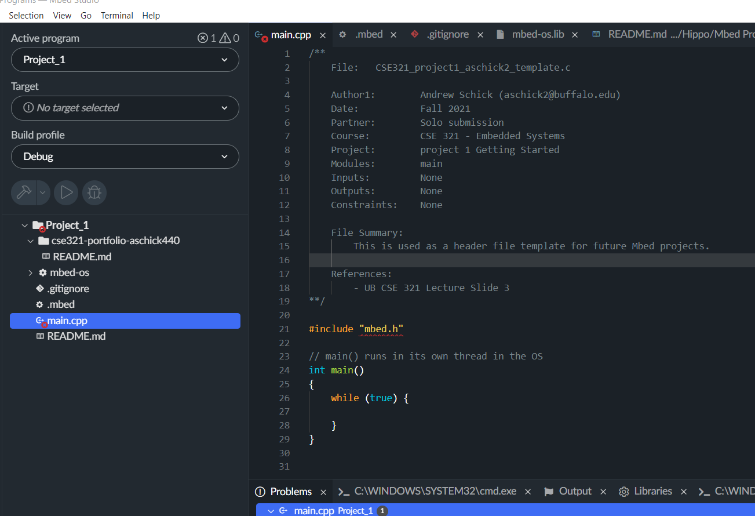

Setting Up Git

Username: aschick440

Planning Practices

**Setup**

Known:

* System: traffic controller based on geese proximity
* Goal: protect the geese
* Inputs: sensors detect traffic and geese
* Outputs: Single light
* Stops traffic in all directions
* Light turns red to stop cars when sensor picks up geese
* Blinking red light means stop and go when geese are out of range

**Ask**

* Since a blinking red light means stop and go, does a solid red light mean stop until it starts blinking?
* Where will this system be implemented? For example, will it be implemented at preexisting stop lights, at places where stop signs are, or at non-intersections?
* At what proximity that the geese are at should all traffic be stopped?
* Is there a reason to have the light function as a stop sign when blinking red instead of a yellow light as a caution?
* Should solar power be used to power the sensors?
* How far away from the road are the sensors and will infrastructure i.e. a pole needs to be built to put the sensors on?
* What type of geese are we protecting?
* Is there a reason to track the traffic via sensors?
* Is this project just focused on the UB North campus or around the town as well?
* What Embedded OS should the system use?
* Where do cars on campus drive the fastest where geese cross?

**Research**

Outputs: Light

* Solid red light, all way complete stop until red light starts blinking.
* Blinking red light, cars must treat it as a stop sign.

Inputs: Sensors

* Geese detected within proximity, set solid red light.
* Geese not detected within proximity, set blinking red light.

Constraints:

* The control system will be implemented at two locations along the Audubon, not at preexisting intersections.
* The system will only track geese movement and will trigger a solid red light when the geese are within 5 meters of the sensor.
* The sensor needs to be able to disseminate between the special geese and other animals, humans, or objects.
* Each of the two stop lights will need two dedicated poles on either side of the road and a wire to connect the light in the middle.
* There will be one sensor per pole facing away from the road.
* The sensors and light will be powered via solar panels lying atop the poles.
* The embedded OS in use will be Mbed.

**Plan**

1. Before Implementing the design, a 6-month study will take place tracking the movement patterns of the geese to ensure the traffic control systems are placed in the best locations.
2. During the study a team will implement a computer vision system that is capable of disseminating between geese and other objects.
3. Once verified the computer vision system will be implemented in conjunction with the simple traffic control logic.
4. At completion of the study two locations will be chosen for traffic control placement.
5. Draft proposal for project and present to school board.
6. After clearance is given poles will be installed firstly followed by the solar panels and power storage.
7. Finally, the wires, lights, and sensors will be connected and to power and the internet for monitoring.
8. During the first three months, there will be someone constantly monitoring the impact of the control system in terms of driver and geese safety, congestion, power consumption, the computer visions effectiveness, and other potentially unexpected consequences.
9. Modify the system if needed and create report for school board on the project.

Coding Practices